CONTAINERIZE THE APP-CREATING DOCKER IMAGE FOR FLASK APP

|  |  |
| --- | --- |
| **TEAM ID** | **PNT2022TMID22972** |
| **PROJECT NAME** | **SKILL AND JOB RECOMMENDER** |

Setup Flask and Dockerfile

Make Project Folder

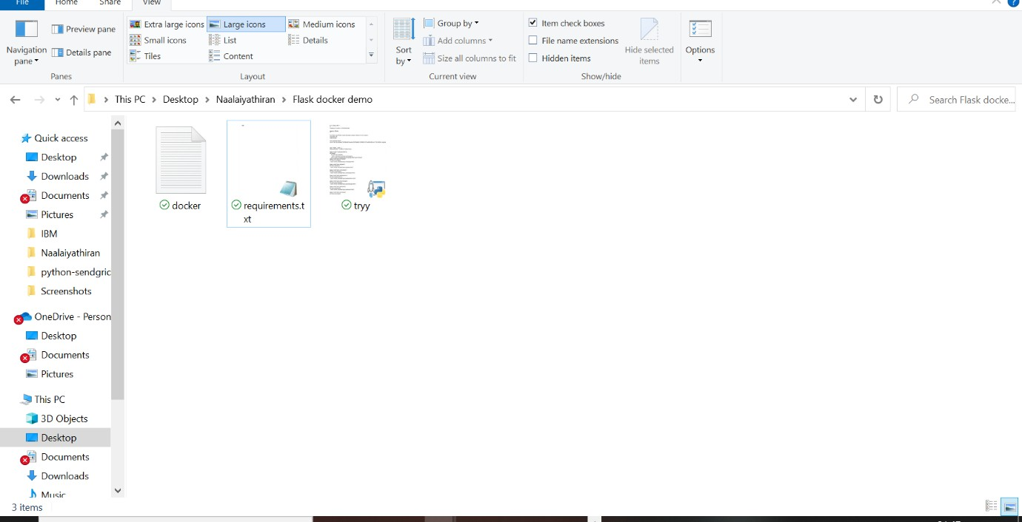

Test the flask app

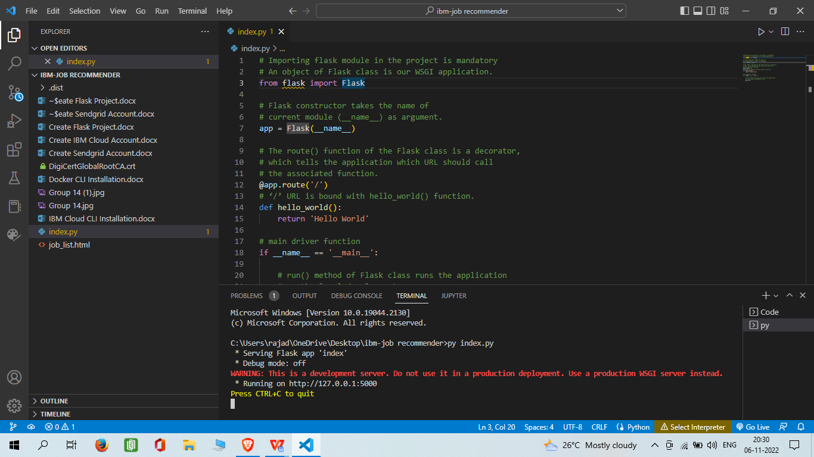

Run the docker image we just created.

